Lab Series No. 8

*Lab 8 –Dictionaries in Python.*

**Programming Exercise**

1. Design a dictionary of your family. Once you get the printout update family dictionary with your grandparents (maternal and paternal) including uncles and aunts (maternal and paternal).

**CODE:**

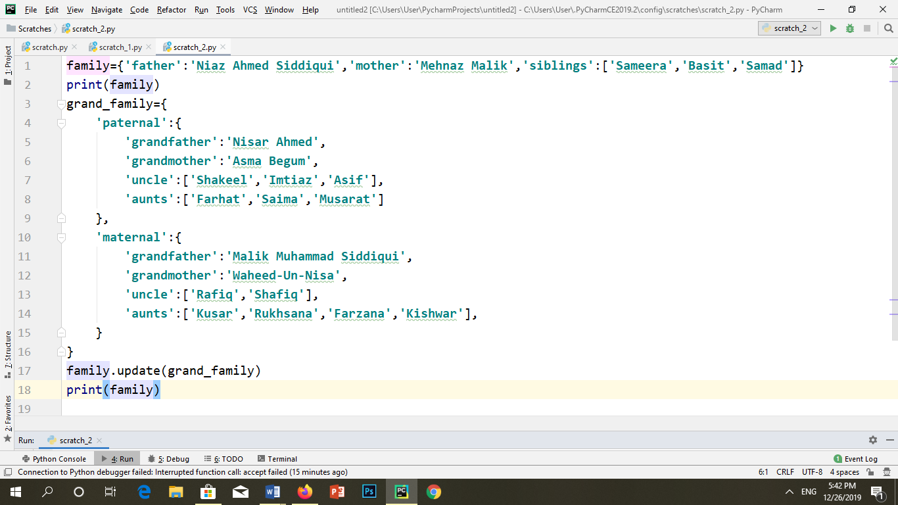

**OUTPUT:**

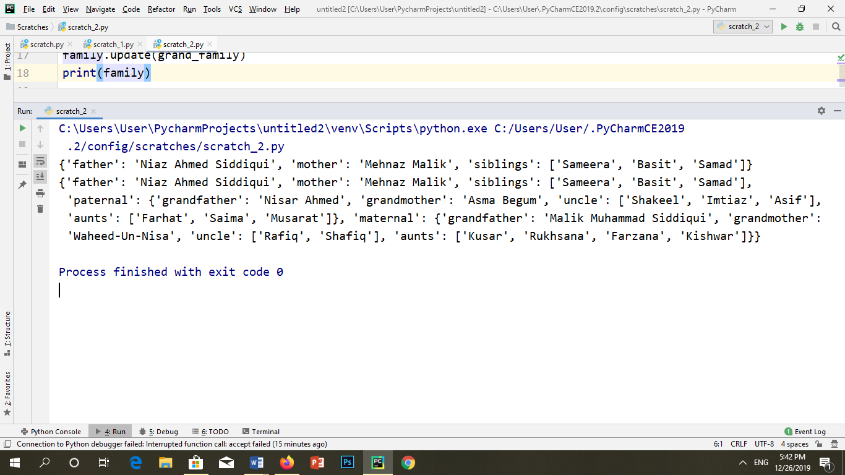

2. Write a function to design a personal phone directory of your parents and friends. You must add 12 members. Then make a function to delete a member from a telephone directory. Print total number of members in your personal phone directory.

**CODE:**

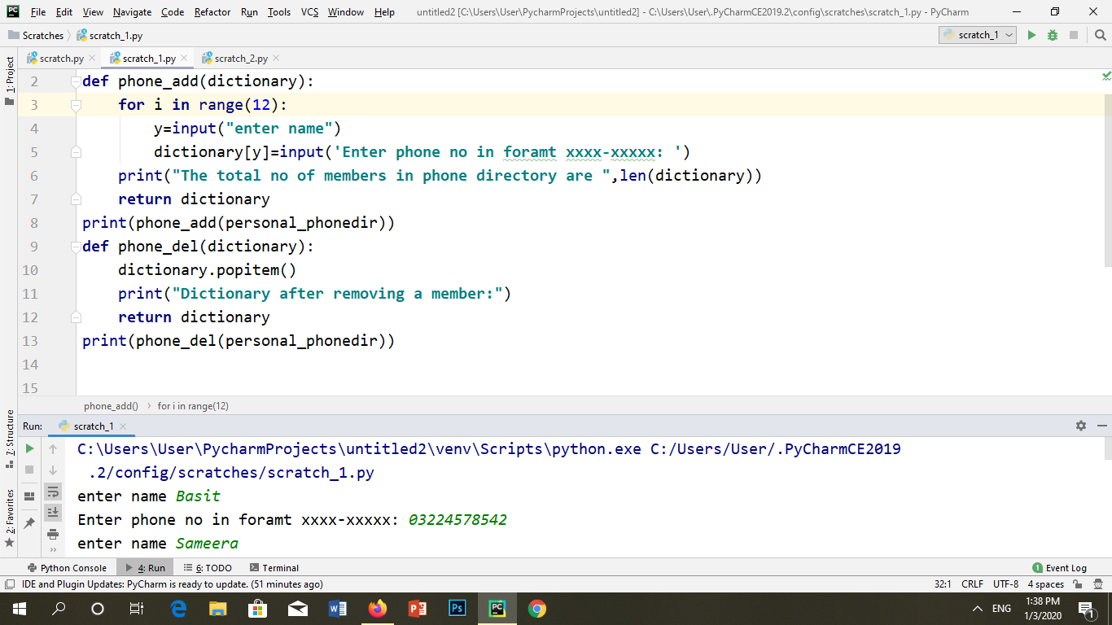

**OUTPUT:**

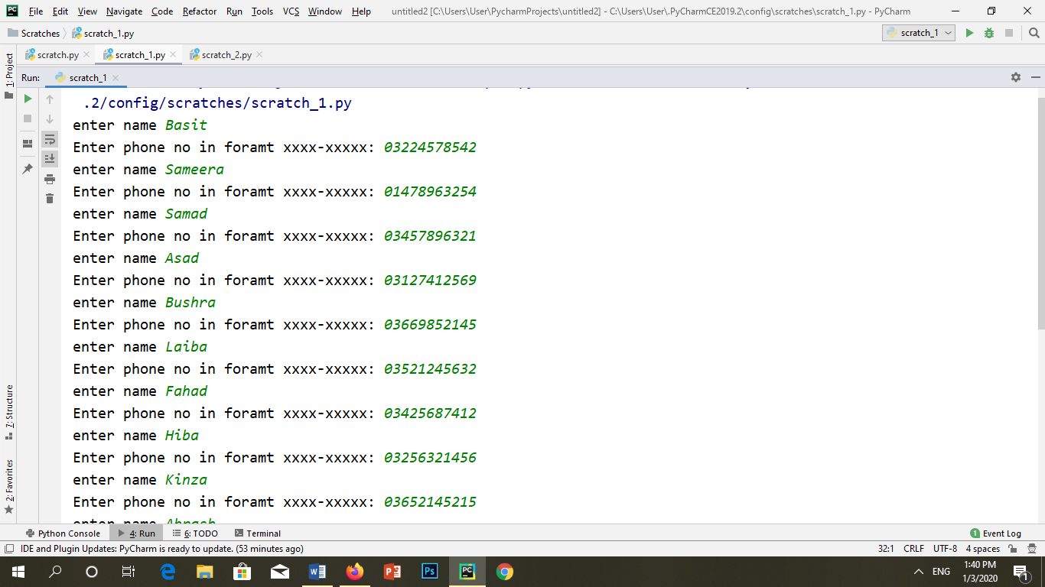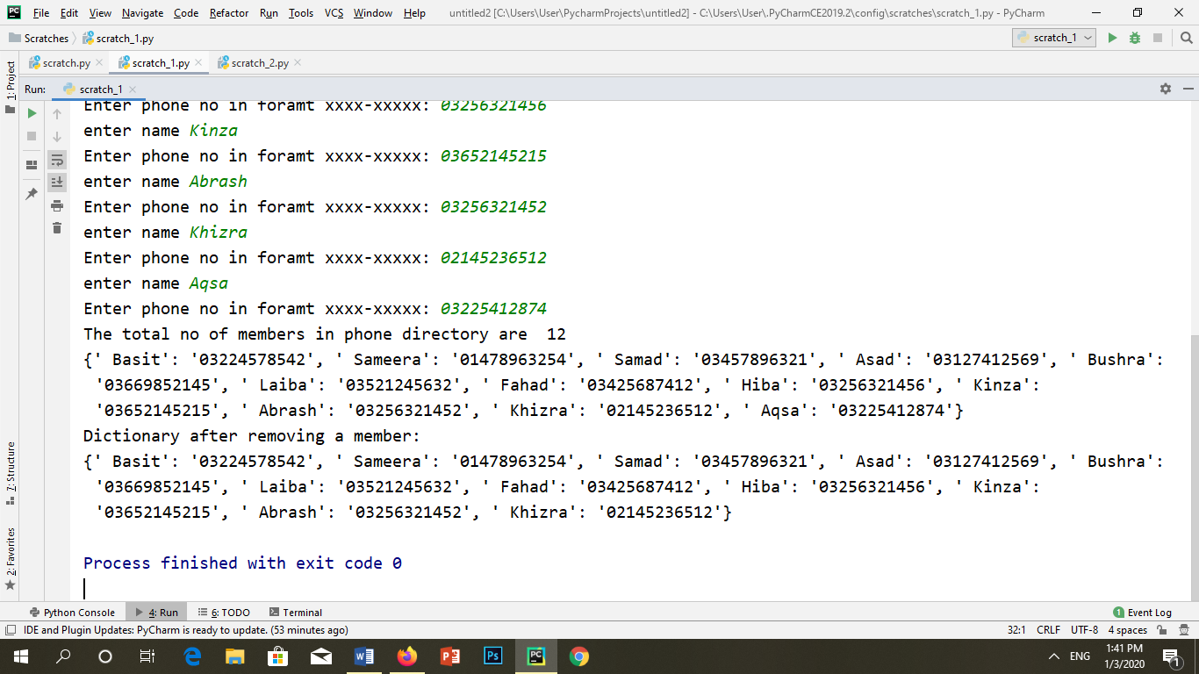

3. Write a function hexASCII () that prints the correspondence between the lowercase characters in the alphabet and the hexadecimal representation of their ASCII code. **Note: *[A format string and the format string method can be used to represent a number value in hex notation.]***

**CODE:**

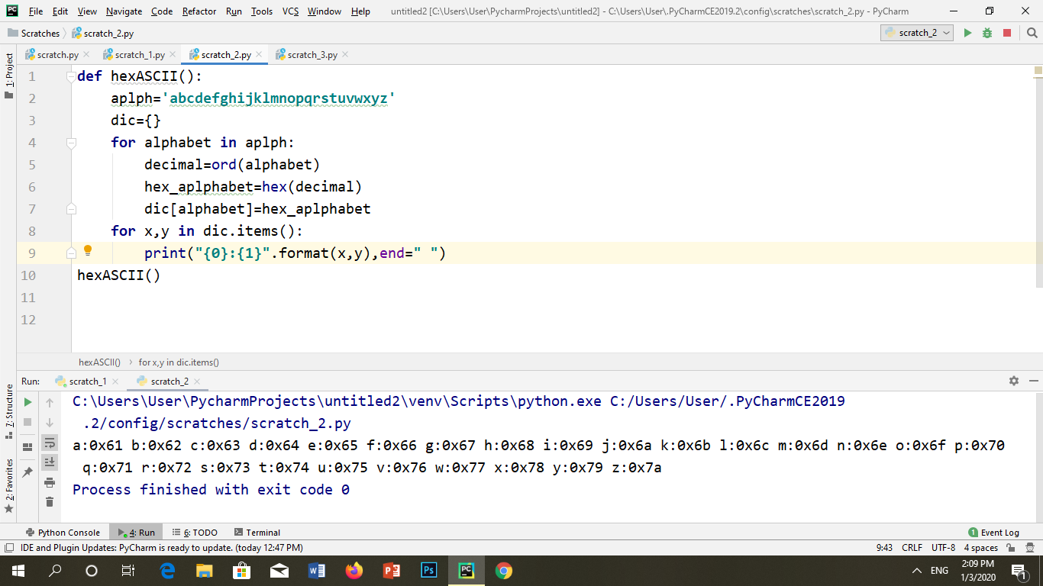

**OUTPUT:**



4. Create double dictionaries one of which is your choice of dishes. Other one is dishes cooked in a week. Compare them and find how many dishes you will get of your choice to be cooked in next week. Print the name of those dishes as well.

**CODE:**

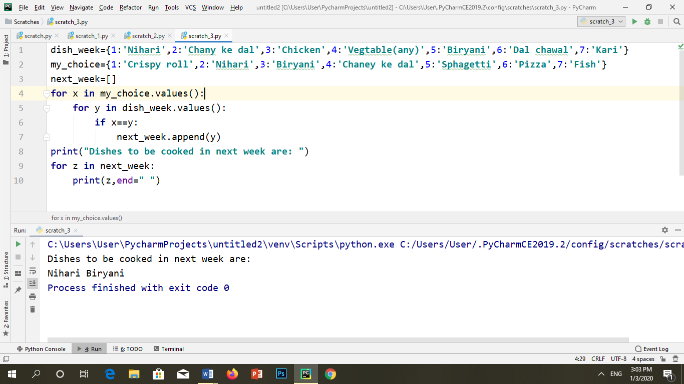

**OUTPUT:**



5. Design a list of guests with family members on your sister wedding. Each family members must be counted. Your parents have made a list of guests and you have made another list. At the end compare both the list and find the common guests which both of you have invited and count them once. The program will return the number of guest with members and total number of guest. Use functions to perform the required actions.

**CODE:**

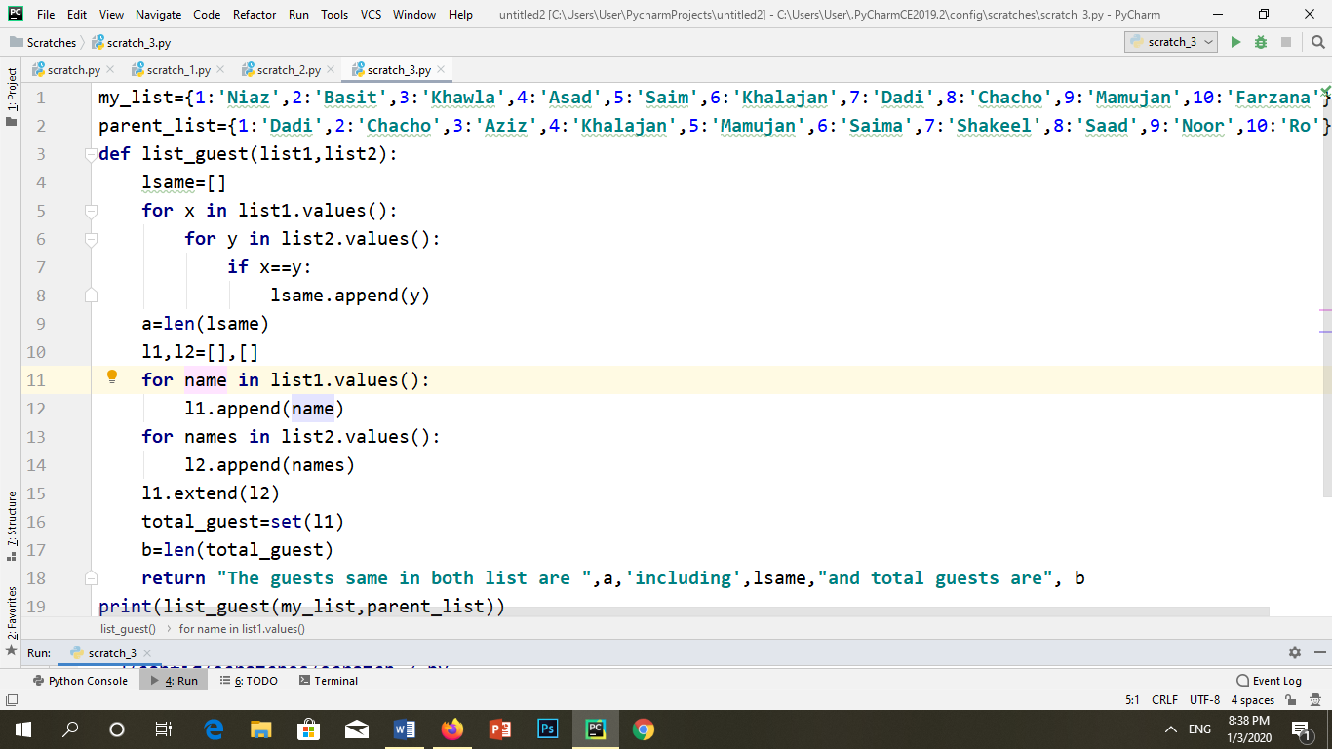

**OUTPUT:**

